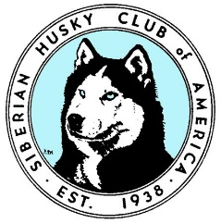
Siberian Husky Club of America, Inc.
Award Application

Award(s) Being Applied for: (please check all that apply)
Title Completion Award:
Scent Work:
_____ Scent Work Container Master Elite (SCME)
_____ Scent Work Interior Master Elite (SIME)
_____ Scent Work Exterior Master Elite (SEME)
_____ Scent Work Buried Master Elite (SBME)

Coursing:
_____ Coursing Ability Excellent Title (CAX)
_____ FAST Cat Title (FCAT)

Tracking:
_____ Champion Tracker (CT)

Other:
_____ Versatile Companion Dog 1 Title (VDC1)
_____ Versatile Companion Champion (VCCH)

List Date & Trial where Title was Completed:

Dog’s AKC Registered Name as it should appear on Award:
______________________________________________________________________
Award Applicant/Owner/SHCA Member: _____________________________________
Address: ______________________________________________________________
Phone Number: ______________________ E-Mail: __________________________
Date (month/year) applicant became an SHCA Member: ________________________
Signature: _______________________________________ Date: _________________

