Applicants for the 2022 Show Year,
This form is for any of the Performance Awards. You must have exhibited the same Siberian Husky for the three qualifying trials. Please provide all requested information for the specific award you are applying for; Top Scoring in Agility, Top Scoring in Obedience, Top Scoring in Rally. You may apply for any or all of the awards on this one form. The winner will be announced at the Annual Banquet of the National Specialty. The deadline for all applications is July 26th, 2023. Applications can be sent by US mail or email. Thank you for your contribution to our sport and incredible breed, by taking the time to learn, exhibit, and compete in performance as a Junior Handler! Junior Handlers are the future of our sport, and the foundation for the preservation of our breed.
So, thank you!
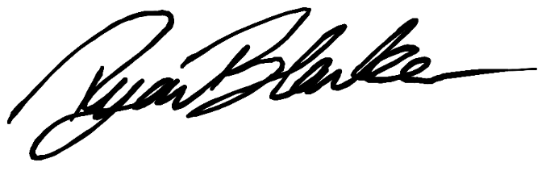

Ryan Blanker
SHCA Junior Showmanship Committee Chair

For more information, any questions, or to email a completed application please email us at shcajrs@gmail.com.
Or mail completed applications to:
Ryan Blanker
456 Mt. Hermon Station Rd.
Northfield, MA 01360

Please make sure to fill out and attach all pages of the following application and don’t forget to sign and fill out the Sponsor Form!

All the Performance Awards qualifying trials must fall within the Jan 1st – Dec 31st time frame. You may exhibit different dogs for the different awards, however, you must only include trials exhibiting the same dog for that one award.

Junior Handler Name:_________________________________________ Date: _____________
Address: ______________________________________________________________________
City:_______________________________ State:_________________ Zip Code:____________
Email: ________________________________________ Phone Number:___________________
SHCA Sponsor Name:___________________________________________________________
Top Scoring in Agility
Trial Date | Trial/Club Name | Class | Score
1.
2.
3.
Registered name of dog ______________________________________________________________________________
Top Scoring in Obedience
Trial Date | Trial/Club Name | Class | Score
1.
2.
3.
Registered name of dog ______________________________________________________________________________

Top Scoring in Rally
Trial Date | Trial/Club Name | Class | Score
1.
2.
3.
Registered name of dog ______________________________________________________________________________
Each Junior must fill out this form and have a member of the SHCA fill out the Sponsor Form. In accordance with SHCA annual awards, only members are eligible to apply/receive, the exception are the Junior Showmanship Program Awards, where a Sponsor for the Junior enables eligibility.

If you have any questions please feel free to contact the Committee Chair before the application deadline.

Please make sure to fill out all required information legibly and completely, and send by the posted deadline.

By signing below, I _________________________ hereby attest that to the best of my knowledge
(print name)
the information provided is both accurate and true.

___________________________________________ _______________
Signed Date

Award Application – Sponsor Form
All Juniors applying MUST have an SHCA Sponsor. If no family member is an SHCA member, the Junior must ask a current SHCA member to sponsor them for this award application to be deemed complete.
This Sponsor Form may be used for any award application, and to eliminate redundancy, multiple awards for the same year.
Name of SHCA Sponsor: ____________________________________________________

I, ____________________________, agree to sponsor _________________________, knowing this sponsorship is solely for this specific award year.

I, ____________________________, know this Junior Handler to be conscientious in their care of all dogs exhibited, and to adhere to the AKC Code of Sportsmanship as well as conduct themselves with respect and integrity in all aspects of the sport.

_______________________________________ ___________________
Signed Date

